Product Service Codes (PSCs) Management

Standard Operating Procedures

November 30, 2017

1. Introduction 2
1.1 Purpose 2
1.2 Background 2
2. Applicability 3
3. Roles and Responsibilities 3
4. Governance 5
5. Cycle for PSC Changes 5
Chart 1 - PSC Change Schedule 5
Diagram 1 - Work Flow 7
6. Overview of the PSC Change Process 8
7. Procedures 10
Chart 2 - PSC Update/Change Procedures 11
8. Summary of Changes to PSC Codes 15
Appendix A: Glossary 16
Appendix B: Web Form – “Request for PSC Changes” 18
Appendix C: Web Form – “Program Support Code Change Analysis” 19
Appendix D: Product Services Code Spreadsheet – Oct 2017 20
Appendix E: Category Manager Chart 21
Appendix F: Sample - Public Notice for GSA Interact Posting 23
Appendix G: Sample – Inform Users 24

Introduction

1.1 Purpose
The purpose of this Standard Operating Procedures (SOP) is to document the process for the administration and management of the Product Service Codes (PSCs) to ensure the accurate reporting of Federal spending data related to procurements. To maintain the flexibility for future changes, the PSCs may be added, revised, or deleted to increase the accuracy of reporting. By ensuring periodic updates, the PSCs are expected to improve system usability by minimizing the use of miscellaneous PSCs when a more specific one is available, leading to more accurate reporting.

1.2 Background
The Federal Government uses more than 3,000 PSCs to describe the different types of products and services purchased by the federal government. These codes are reported to a variety of federal systems, including agencies’ contract writing systems, the Federal Procurement Data System – Next Generation (FPDS-NG) and other Integrated Award Environment (IAE) systems, and industry systems. The PSCs are instrumental for reporting; are critical for government leadership to understand how federal dollars are spent; and help the Federal Government determine how much money is being spent on specific products or services.

The PSCs are also used to study existing trends in Federal spending; report on international agreements; analyze regulatory burden; and reflect changes in technology and terminology. The PSCs identify commodities with environmental or other attributes; used to generate ad hoc, statutory, and international reporting; and link procurement systems to contracting and financial data. The PSCs provide procurement data to USAspending.gov. Civil and defense logistics operations and processes use PSCs extensively, especially for tracking quality and item pricing of parts.

Historically, the PSCs refreshes were managed by the General Services Administration (GSA) and the Department of Defense (DoD) Defense Logistics Agency (DLA). The PSCs were divided into three sections in the GSA PSC Manual: Section A - Research & Development, Section B - Services, and Section C - Products. The GSA managed the PSCs in Section A - Research & Development and Section B - Services while the DLA managed the PSCs in Section C - Products.

The changes made by DLA to the PSCs in Section C - Products were incorporated verbatim into the GSA PSC Manual since these PSCs were based on the list of Federal Supply Classes (FSCs) managed by DLA. The FSCs are four-digit codes used to group products into logical families for supply management purposes. The FSCs are also used to classify government standards documents into categories, to help manage them more easily.

In 2015, the federal governmentwide shift to category management began to provide a coordinated, strategic approach to governmentwide purchasing, by identifying core categories of spend and developing heightened levels of expertise, sharing best practices, providing streamlined solutions, and managing supply and demand for each of the categories.

The GSA, the Department of Homeland Security (DHS), the Office of Personnel Management (OPM), the Department of Veterans Affairs (VA), and research and development (R&D) experts from the R&D Federal community are the Category Managers for Common Spend Government categories (Categories 1-10 and 17). These experts are aware of the latest advances in their respective categories and area of spend; the coding needed to further their knowledge of government spend; and the insight needed to manage spend to support the government in making better buying decisions.

The DoD is Category Managers for the PSCs in Defense-Centric Spend Categories 11-16, 18, and 19; however, the Defense Logistics Agency (DLA) is DoD’s designated SME who specifically manages the addition, deletion, and revision of PSCs correlated to supply FSCs in Categories 11, 12, 13, 14, and 19. DLA is also responsible for the management and operation of the Federal Logistics Information System (FLIS), which incorporates the data requirements for cataloging, supply, and other logistics support needs of the DoD, civil government agencies, and participating North Atlantic Treaty Organization (NATO) countries.

GSA is now making use of the category management infrastructure and interagency governance to improve the process for updating the PSCs. Refer to the PSC spreadsheet, which shows the alignment of the PSCs among the 19 spend categories. This includes 11 common governmentwide spend categories and eight defense-centric spend categories.

By way of this SOP, GSA is implementing a standardized process for updating the PSCs by utilizing the category expertise of these Subject Matter Experts (SMEs). This includes the updating of PSCs for the product and/or services in all 19 spend categories, alleviating the DoD and the GSA of the burden of managing all the PSCs and aligning the management of the codes with the strategic principles of each category management.

Applicability
The PSC SOP applies to all:

- Subject Matter Experts (SME)
- Department of Defense (DoD)/Defense Logistics Agency (DLA).
- Integrated Award Environment (IAE) Team
- Procurement Committee for e-Government (PCE)

Roles and Responsibilities
The Category Managers are experts from the GSA, the DoD, the Department of Homeland Security (DHS), the Office of Personnel Management (OPM), the Department of Veterans Affairs (VA), and R&D experts from the R&D Federal community. These experts are aware of the latest advances in their respective categories and area of spend; the coding needed to further their knowledge of government spend; and the insight needed to manage spend to support the government in making better buying decisions. For the purposes of this SOP, the Category Managers are the Subject Matter Experts (SMEs), and therefore the term SMEs refers to both Category Managers and non-Category Managers.

Outlined below are the roles and responsibilities of all parties involved in the PSC Update Process.

- SMEs
  - lead the review and analysis of the proposed changes to PSCs within a specific category,
  - document analysis, recommend changes, and state the rationale for recommendations,
  - provide final changes (numbering, definition, and naming) to PSCs,
  - notify stakeholders of PSC changes and
  - update the PCE and other stakeholders on the proposed changes, especially issues related to the collection, use, dissemination, and display of procurement data.

- DoD
  - is the SME for the PSCs in Defense-Centric Categories 11-16, 18, and 19, and designates DLA as its SME who manages the addition, deletion, and revision of PSCs correlated to supply FSCs in Categories 11, 12, 13, 14, and 19,
    - DLA manages and follows the DoD policies and processes to analyze and approve proposed changes to PSCs related to supply FSCs, and
  - handles change requests for these PSCs in accordance with the DoD’s established review, governance, and approval processes, and
  - follows the established DoD policies, governance, and processes to analyze and approve propose changes to codes.

- Integrated Award Environment (IAE)
  - is the central coordination point for all users (Federal and public) to submit requested changes to the PSCs,
  - publicizes PSC changes in accordance with appropriate regulatory requirements,
  - manages the system updates to IAE’s suite of applications to ensure the timely updating of PSCs, and
  - implements the necessary system changes for the subsequent Fiscal Year (FY), and
  - identifies more data-centric information technology capabilities for updating the PSCs.

- Procurement Committee for e-Government (PCE)
  - provides the final decision on all PSC changes--additions, deletions, and revisions,
  - advises and recommends actions related to the collection, dissemination, and display of procurement data,
  - ensures the proposed data reporting requirements are appropriate and meet functional requirements and operational feasibility, and
  - reviews interim results as needed.

Governance
The updated governance process for the PSCs supports changes in the federal acquisition and procurement data landscape as well as changes in how agencies strategically approach spending decisions. The Procurement Committee for e-Government (PCE) provides guidance, recommendations, and governance over the integrated environment designed to provide efficient and effective access to timely data required by federal procurement professionals. It is the overarching governance and the final decision-maker for adding, deleting, and revising the PSCs in the Common Spend Government categories (Categories 1-10 and 17) and the Defense-Centric categories (Categories 11-16, 18, and 19). If there are disagreements between the SMEs and the PCE regarding changes to the PSCs, the PCE has the final authority on the final resolution.

Cycle for PSC Changes
To ensure the continuous review and refresh of the PSCs, a multi-year scheduling cycle has been developed which will enable all PSC categories to be reviewed at least once every five years beginning in fiscal year 2018. PSCs in categories that have more frequent industry changes will be reviewed every two years. This schedule has been structured to ensure that the IAE can efficiently process changes on an annual schedule.

The cycle for refreshing the individual codes is below. All cycles begin in FY 2018 unless otherwise noted. Chart 1 shows the schedule and the SMEs for the respective common governmentwide spend categories and defense-centric categories.

Chart 1 - PSC Change Schedule
Category Number | Categories (as defined by Category Management) | Schedule | SMEs
Common Government Spend Categories
1 | Information Technology | FY 2018 & every 2 years | GSA Category Manager
2 | Professional Services | Every 2 years | GSA Category Manager
3 | Security and Protection | Every 2 years | DHS Category Manager
4 | Facilities & Construction | Every 5 years | GSA Category Manager
5 | Industrial Products and Services | Every 5 years | GSA Category Manager
6 | Office Management | Every 5 years | GSA Category Manager
7 | Transportation and Logistics Services | Every 5 years | DoD Category Manager
8 | Travel and Lodging | Every 5 years | GSA Category Manager
9 | Human Capital | Every 5 years | OPM Category Manager
10 | Medical | Every 5 years | VA and DoD Category Managers
17 | Research and Development (R&D) | FY 2018 & every 5 years | Federal R&D Community of Practice
Defense-Centric Spend Categories
11 | Aircraft, Ships/Submarines, Land Combat Vehicles | TBD | DOD Category Manager
12 | Weapons & Ammunition | TBD | DoD Category Manager
13 | Electronics & Communication Equipment | TBD | DoD Category Manager
14 | Sustainment S&E | TBD | DoD Category Manager
15 | Clothing, Textiles & Subsistence S&E | TBD | DoD Category Manager
16 | Miscellaneous S&E | TBD | DoD Category Manager
18 | Equipment Related Services | TBD | DoD Category Manager
19 | Electronic Communication Services | TBD | DoD Category Manager

Any request received after October 31st will be considered an “out of cycle” change request, and they may not be processed in time to be implemented for the next fiscal year.

For the “out of cycle” change requests, the SMEs may conduct a review based on the availability of resources. If resources are available, the SMEs follow the applicable steps. If resources are not available, the SMEs will notify IAE that the proposed PSC change requests will need to be added to the next fiscal year’s change requests.

The Diagram 1 – Work Flow illustrates the work flow for change requests for PSCs. Section 7 outlines the specific roles and responsibilities for the detailed tasks, the time frames, documentation, approvals, and implementation dates.

Diagram 1 - Work Flow

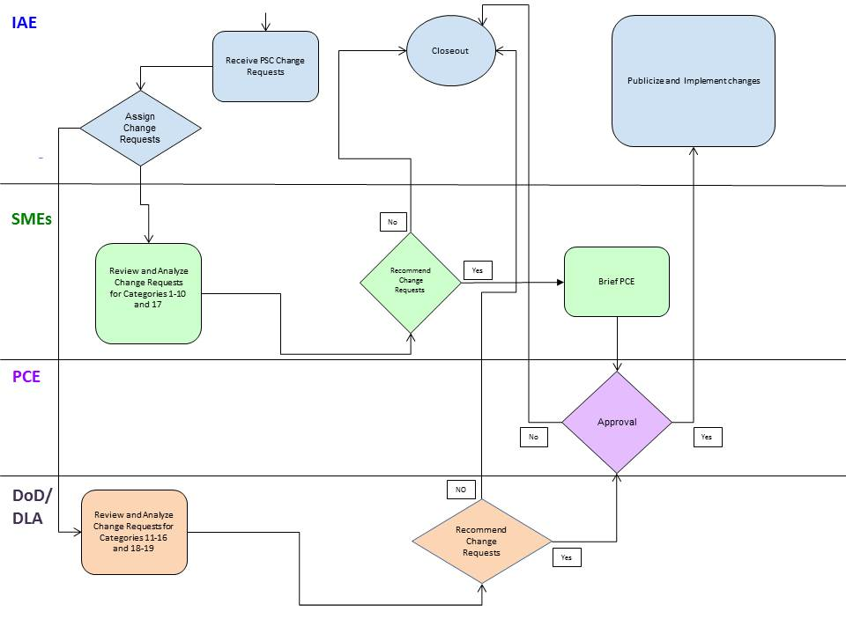

Overview of the PSC Change Process

1) Request Submission and IAE Assignment
In order for changes to the PSCs to be considered for the upcoming fiscal year, users must submit their requests during the 30 day opening period from October 1st to October 31st using the web form “Product Service Codes (PSC) Change Request” available on the IAE Federal Service Desk (FSD) website at FSD.gov.

All applicable sections of the web form “Product Service Codes (PSCs) Change Request” must be completed to facilitate the analysis of the proposed PSC changes. If supporting documentation does not fit in the templated sections of the web form, please state in the applicable sections “see attachments for additional supporting information.”

With assistance from the Category Management Program Management Office, IAE will assign the proposed change requests to the appropriate SME for analysis. When IAE provides the SME in charge of the review with the proposed change requests, IAE will provide the web form “Program Support Code Change Analysis” so the SME can capture the analysis. IAE will also register the proposed change request in its tracking system once the proposed change requests are assigned to the applicable SME for analysis.

Defense Centric Spend Categories

Any change requests received for the PSCs in the Defense-Centric Spend Categories will be forwarded to the DoD’s SMEs for action. Change requests to specifically update PSCs correlated to supply FSCs are forwarded to the DLA to handle. DLA will provide IAE a copy of change requests for PSCs related to supply FSCs submitted directly to DLA so IAE can register these proposed requests in its tracking system.

Off Cycle Change Request

Any request received after October 31st will be considered an “out of cycle” change request and may not be processed for the next fiscal year’s implementation. SMEs may conduct a review based on the availability of resources. If resources are available, the SMEs shall follow the applicable steps. If resources are not available, the SMEs will notify IAE that the proposed PSC change requests will need to be added to the next year’s FY change requests.

2) Review and Analyze
Once a PSC change request has been assigned, the SMEs will review and analyze the proposed changes. To determine whether a PSC should be changed, the SMEs’ analysis may include, but is not limited to, the following:

- analyze the existing PSCs for clarity,
- determine whether industry changes or policies dictates a change to the PSCs,
- identify how the purchases of the commodity are currently captured and coded,
- ensure content changes are aligned properly with industry or policies,
- assign new PSCs or retain the existing PSCs,
- validate the accuracy of the PSC’s name, content, and definition,
- identify data reporting requirements or other attributes, and
- recommend or not recommend the proposed PSC changes.

The SMEs will follow their established review and analysis processes for their respective categories.in analyzing the proposed change requests. SMEs will use the web form “Program Support Code Change Analysis” to capture their analysis and recommendations for the change request. The SMEs’ review, analysis, coordination, and concurrences must be completed by the timeline in Section 7.

When the review and analysis are complete, the SME in charge of the review must inform IAE, via PSC-Codes@gsa.gov, of their recommendation. Provide the rationale on the web form “Program Support Code Change Analysis”. Additional supporting data supporting the SME’s recommendation on the PSC change requests may be submitted to PSC-Codes@gsa.gov.
If the proposed change request is recommended, the SME in charge of the review or representatives must brief the PCE on the recommendations. To schedule a meeting to brief the PCE either virtually or in-person, the SME shall submit a request to PSC-Codes@gsa.gov.
If the proposed change request is not recommended, the SME in charge of the review is required to provide the rationale on the web form “Program Support Code Change Analysis” and inform IAE so it can update its tracking.
Defense Centric Spend Categories

Changes requests for the PSCs in the Defense-Centric Categories will be handled in accordance with DoD’s established processes. The DoD SMEs, which includes DLA, will either recommend or not recommend the proposed changes to the PSCs. If the proposed change request for the PSCs is recommended, the DoD SMEs will brief the PCE to get the PCE’s approval. If the proposed change request is not recommended, the DoD SMEs will provide their rationale for the rejections, and inform IAE so IAE can update its tracking and inform the user.

3) SMEs Briefings and PCE Approvals
For all recommended PSC changes, all SMEs must brief the PCE to obtain its approval. The PCE may require additional information and clarifications before the briefing. The PCE will document its concerns with the proposed changes to the PSCs.

If the PCE’s provides its approval on the proposed PSC changes, the SMEs shall provide the IAE all required documentation, including the PCE’s approval, so that the IAE can proceed with publicizing the proposed PSC changes. If the PCE rejects the proposed changes to the PSCs, the PCE will provide a brief explanation for its rejection.

Once the PCE’s determination has been made, the SMEs will then inform IAE, via PSC-Codes@gsa.gov, of the approval or rejection so IAE can update its tracking and inform the user of the final decision on the proposed change request.

4) Publicize and Implement Changes
IAE will follow the applicable and appropriate publicizing processes to get public feedback on the proposed changes to the PSCs. Using the draft in Appendix F: Sample – Public Notice as a guide, IAE will create a public notice indicating which PSCs are being added, deleted, or revised. The SMEs will provide the IAE with the applicable supporting documentation so IAE can incorporate these changes into its public notice.

IAE will posts a public notice to GSA Interact (interact.gsa.gov) or a comparable platform for 30 days and seek public feedback. After the 30 day comment period, IAE will coordinate with the appropriate SME to adjudicate comments all comments and questions received.

If necessary, the SMEs brief the PCE if additional changes were made to the PSCs due to feedback from the publicizing process. The SME will repeat the steps in “Section 3.0 SME’s Briefing and PCE Approvals” to get brief the PCE and get its approval.

IAE will implement the approved and final PSC changes in IAE’s suite of systems and applications. IAE does not enhance its systems in the fourth quarter of the fiscal year so all system changes must be completed and tested for the October 1st deployment.

IAE will post a notice, such as the draft in Appendix G: Sample – Inform Users, through GSA Interact, IAE’s Change Control Board weekly updates, FAI newsletter, and FSD.gov, to inform users and stakeholders that the new codes are ready for use.

Defense Centric Spend Categories

Any changes to PSCs related to supply FSCs must be coordinated with DLA in order to ensure DLA’s system is updated. Approved changes made to PSCs related to supply FSCs will be posted on DLA’s website:

http://www.dla.mil/HQ/InformationOperations/Offers/Services/FIC/IIG/CFLetters.aspx

Procedures
The chart below provides the detailed steps, including the recommended timelines, for updating the PSCs in the Common Government Spend Categories. Some of these steps can be performed concurrently, reducing the time needed for the overall process. All PSC changes are processed in accordance with procedures described below.

Chart 2 - PSC Update/Change Procedures
Steps | Role/ Responsible Parties | Description | Duration (calendar days) | Deadline
1.0 Collect PSC Change Request | IAE | - Open period for receiving proposed changes requests.  - Logs requests into IAE tracking system. | 30 Days | October 1st– October 31st
1.1 Assign PSC Change Requests | IAE | - With assistance from the Category Management Program Management Office, assign the proposed change requests to the appropriate SMEs for analysis.  - If applicable, reassigns the request to SMEs best suited to review the proposed PSC change request.  - Provide the web form “Program Support Code Change Analysis” to the SME so the SME can capture the analysis  - Change requests received for PSCs in the defense-centric categories will be forwarded to DoD’s SMEs for action, and change requests to update PSCs correlated to supply FSCs are specifically forwarded to the DLA. | 5 Days | October
1.2 (b) Out of Cycle Reviews | SME | - Any request received after October 31st will be considered an “out of cycle” change request and may not be processed for the next fiscal year’s implementation.  - SMEs may conduct a review based on the availability of resources.  - If resources are available, the SMEs shall follow the applicable steps.  - If resources are not available, the SMEs will notify IAE that the proposed PSC change requests will need to be added to the next year’s FY change requests. | 15 days | November 1st – November 15th
2.0 (a) Standard Review Cycle | SME | - Receives PSC change requests from IAE.  - Reviews and analyzes the proposed content changes.  - Use web form to document analysis.  - DoD’s SMEs handle the analysis of PSC change requests for in accordance with the DoD’s established review processes. | 30 days | November - December
2.1 SME’s Recommendations | SME | - Provides recommendations and analysis on proposed changes to the PSC.  - Informs IAE, via PSC-Codes@gsa.gov, of the decision to proceed or not proceed with proposed changes.  - Coordinates with IAE to notify users of decisions and track status of reviews.  - DoD SMEs coordinates with IAE to notify users of decisions and track status of reviews. | 30 days | December
2.2 Track Progress | IAE | - Updates the tracking based on the SME’s recommendations.  - For changes not recommended, receive a brief explanation from the SME, and inform the users of the final decision, via FSD.  - Close out the request in the tracking system.  - For recommended changes, schedule a meeting to brief the PCE either virtually or in-person,  - Submit meeting request through PSC-Codes@gsa.gov. | 5 days | January
3.0 Brief the PCE | All SMEs | - Brief the PCE to obtain its approval.  - PCE will document its rationale.  - Once the PCE’s determination has been made, the SMEs will inform IAE, via PSC-Codes@gsa.gov.  - For approvals, provide the IAE all required documentation needed to proceed with a public notice.  - For rejections, provide IAE with the PCE’s rationale so IAE can inform the users of the final decision, via FSD. | 30 days | January - February
3.1 Track Progress | IAE | - If the PCE’s provides its approval on the proposed PSC changes, obtain all required documentation from the SME to publicize the proposed PSC changes.  - Updates the tracking to show IAE is responsible for publicizing PSC changes.  - For rejections, informs the user of the final decision, via FSD, and close out the request in the tracking system.  - Update tracking and inform the user of the final decision on the proposed change request. | 10 days | February
4.0 Develop Public Notice | IAE | - Follows the applicable processes to get public feedback on the proposed changes to the PSC.  - Reference Appendix F: Sample – Public Notice as a guide to request feedback on the changes to PSCs.  - Coordinates with IAE’s internal communication team and SME to create content. | 30 Days | March - April
4.1 GSA Policy Review | IAE | - As applicable, send the public notice to GSA’s Policy Office to determine whether regulatory changes are needed for the proposed PSC changes.  - GSA’s Policy Office’s official approval on the notice may be provided via email. | 5 days | March
4.2 GSA Legal Counsel’s Approval | IAE | - As applicable, seek GSA’s General Counsel’s review of the public notice for legal sufficiency.  - GSA’s General Counsel’s official approval on the notice may be provided via email. | 5 days | March
4.3 Finalize Public Notice Package | IAE | - Final package for posting with the public notice may include the following:  - Approved public notice for the GSA Interact  - Other supporting documents:  - e.g. Attachments with the PSC changes, revised PSC Manual, etc. | 15 days | April
4.4 Publish Public Notice | IAE | - IAE reviews, approves, and post the final public notice to GSA Interact (interact.gsa.gov) or a comparable platform for 30 days.  - Informs the SME of the public notice.  - Direct all public feedback to PSC-Codes@gsa.gov, and Monitor inbox and blog for comments and questions.  - IAE and SME notify stakeholders of posting of the public notice. | 30 days | April-May
4.5 Review Comments | IAE | - After the 30 day comment period, coordinate with the appropriate SME to adjudicate comments and questions received.  - Post responses to GSA Interact.  - Updates the tracking system to show comments were posted. | 30 days | May - June
4.6 Brief PCE  (If Necessary) | SME | - If necessary, repeat the steps in “3.0 Brief PCE”. | 30 days | June
4.7 Track Progress  (If Necessary) | IAE | - If necessary, repeat the steps in “3.1 Track Progress”. | 10 days | July
4.8 Implementation | IAE | - After the PCE provides it approval, IAE implements the approved and final PSC changes in its suite of systems and applications.  - No system changes in the fourth quarter (4Q).  - Any changes to PSCs related supply codes must be coordinated with DLA in order to ensure DLA’s system is updated. | 60 days | August - October 10th
4.9 Publicizing the Changes | IAE | - Communicate the changes to users and stakeholders using various means and platforms to indicate that the new PSCs are ready for use.  - Reference Appendix G: Sample – Public Notice for publicizing changes.  - Approved changes made to PSC related to supply FSCs will be posted on DLA’s website. | 30 Days | August - September

Summary of Changes to PSC Codes
IAE, as the administrator of the PSCs is responsible for archiving the information related to PSC changes. IAE will retain all legacy data in accordance with record retention requirements. IAE will keep a history of the code changes for analytical, research, and reporting purposes. This historical information will be publicly available on Acquisition.gov at https://www.acquisition.gov/PSC_Manual.

Appendix A: Glossary

- Acquisition.gov – website that provides the Federal acquisition workforces with access to training, news, guidance, resources, and other tools needed to improve their performance and knowledge.
- Category Management Program Management Office – provides overall program management support to Subject Matter Expert (SME) in the governmentwide category management governance structure, and facilitates development and implementation of business rules and processes. It is designed to foster repeatable processes across categories with continual integration of lesson learned.
- Defense Logistics Agency (DLA) - designated as the administrator of the Federal Catalog Program, DLA manages and operates the Federal Logistics Information System, which incorporates the data requirements for cataloging, supply and other logistics support needs of the Department of Defense, civil government agencies and participating NATO countries.
- Federal Acquisition Service (FAS) - integral part of GSA and possesses unrivaled capability to deliver comprehensive products and services across government at the best value possible.
- Federal Cataloging Committee (FCC) – members includes the military services, GSA, and Civil Agencies, and North Atlantic Treaty Organization (NATO), and collaborates with DLA on changes to FSC codes.
- Federal Catalog Program - a single cataloging system within DoD to ensure economical, efficient and effective supply management. It further required that each item repeatedly purchased, stocked or distributed by the government have a unique identifier.
- Federal Procurement Data System - Next Generation (FPDS-NG) - FPDS-NG is a historical database system that federal government agencies use to report data to measure and assess the impact of federal procurement on the nation’s economy, learn how awards are made to businesses in various socioeconomic categories, understand the impact of full and open competition on the acquisition process, and address changes to procurement policy.
- Federal Logistics Information System (FLIS) - provides essential information about supply items including the National Stock Number (NSN), Item Name, Reference/Part Numbers, Commercial and Government Entity (CAGE) codes and other Federal logistics data.
- Federal R&D Community of Practice - an inter-agency group of experts responsible for identifying opportunities for common R&D reporting solutions and to develop tools that can reduce burden, enhance data quality and continuity, and automate reporting processes, while saving time and ensuring high quality consistent data on federal R&D.
- Federal Supply Class (FSC) codes - four-digit codes that are used to group products into logical families for supply management purposes. These codes are also used to classify government standards documents into categories, to help manage them more easily.
- GSA Interact - the official FAS external government-owned, government-designed collaboration platform that allows for an open and transparent GSA FAS integrated collaboration environment using current meaningful and various social media technologies (blog, document sharing, polling, image galleries, video etc.)
- Integrated Award Environment (IAE) – office within the Federal Acquisition Service, Office of System Management, responsible for the management of a suite of electronic systems used in the award and administration of federal financial assistance and contracts.
- Procurement Committee for e-Government (PCE) - a cross-agency group of experts responsible for making decisions and recommendations related to (1) improving the collection and use of procurement data in acquisition decisions and management, (2) increasing transparency and traceability of federal procurement data, (3) development and maintenance of data standards and associated tools, and (4) policies and guidance related to those data and systems.
- Product Service Codes (PSCs) - four-digit codes used describe products, services, and research and development (R&D) purchased by the U.S. federal government.
- Subject Matter Expert (SME) - Federal employees such as a Category Manager, Lead SME, SME Working Group, market expert, or other experts with the experience and expertise related to the specific category or commodity.
- USAspending.gov - the publicly accessible, searchable website mandated by the Federal Funding Accountability and Transparency Act of 2006 to give the American public access to information on how their tax dollars are spent.

Appendix B: Web Form – “Request for PSC Changes”
https://docs.google.com/forms/d/e/1FAIpQLSfEkzQRChTAiE87Kh1aqIedidDg_yv_EVHcGxsfrHJYvfJlJQ/viewform

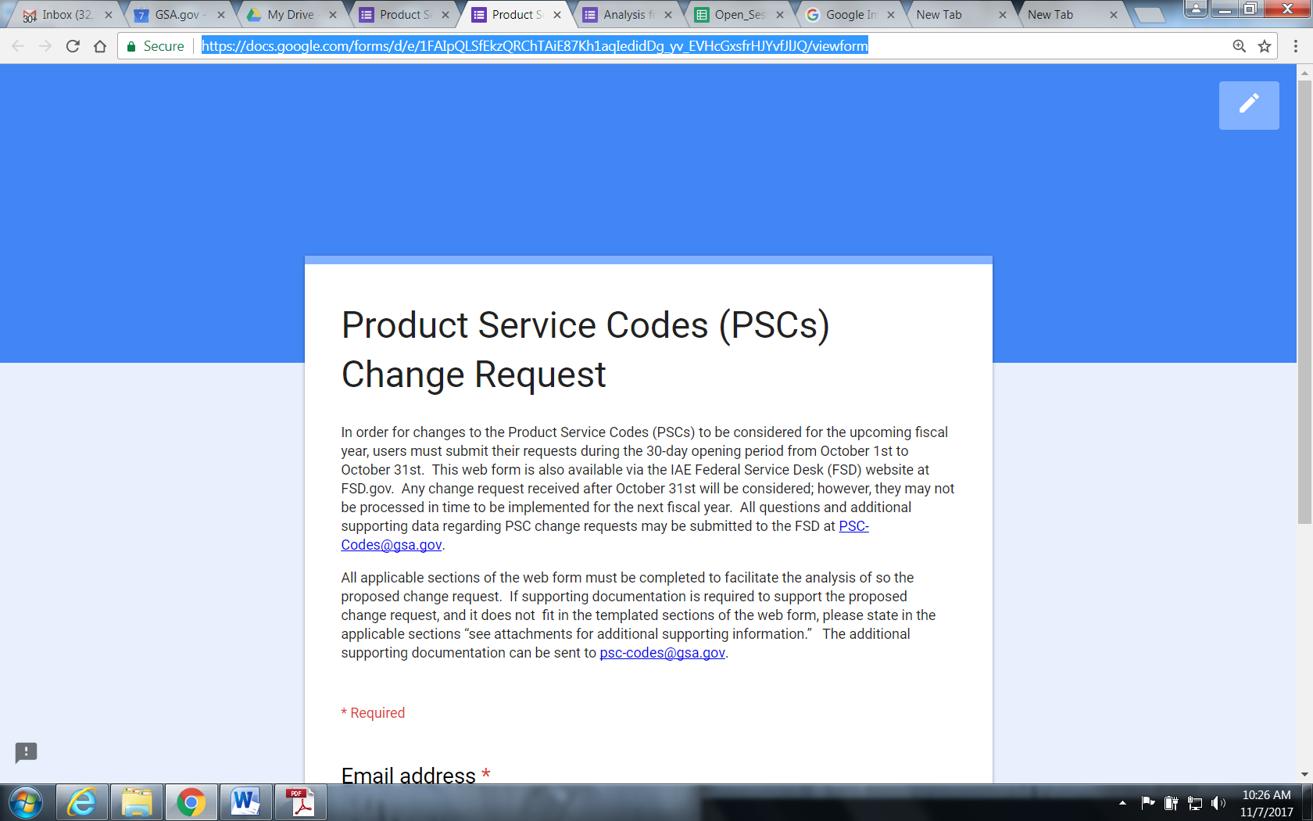

Appendix C: Web Form – “Program Support Code Change Analysis”
https://docs.google.com/forms/d/1VvepaiGjpyCkjYfeNq05zaJl1deBWx7iMsyfGNP9rPc/edit

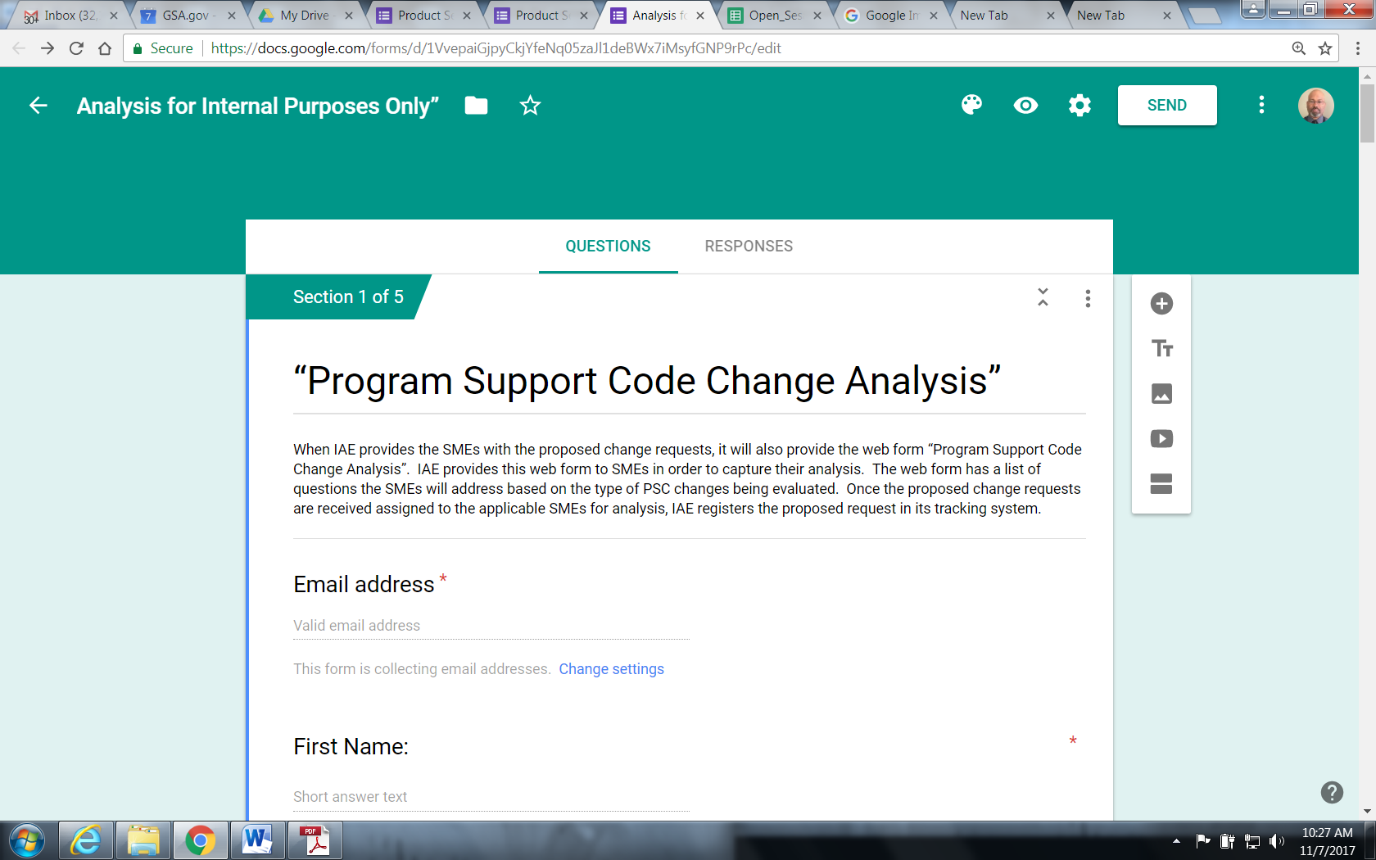

Appendix D: Product Services Code Spreadsheet – Oct 2017
The PSC spreadsheet shows the alignment of the PSC among the 19 spend categories. This includes 11 common governmentwide spend categories and eight defense-centric spend categories.

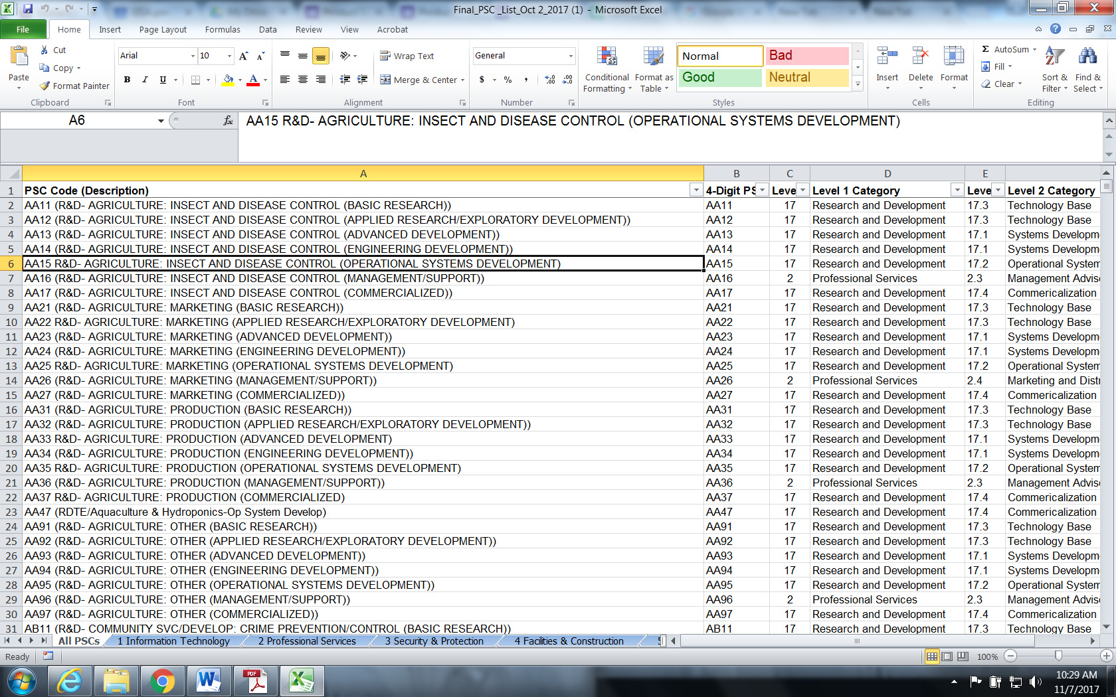

Appendix E: Category Manager Chart
The chart below identifies the points of contacts for the respective common governmentwide spends categories and defense-centric categories.

Category Number | Categories (as defined by Category Management) | Category Points of Contact (POC)
1 | Information Technology | GSA Category Manager  POC: William Zeielinski  William.Zielinski@gsa.gov
2 | Professional Services | GSA Category Manager  POC: Geri Haworth  geri.haworth@gsa.gov
3 | Security and Protection | DHS Category Manager  POC: Tina Cox  tina.cox@hq.dhs.gov
4 | Facilities & Construction | GSA Category Manager  POC: Eric Stonner  eric.stonner@gsa.gov
5 | Industrial Products and Services | GSA Category Manager  POC: Cheryl Roney  cheryl.roney@gsa.gov
6 | Office Management | GSA Category Manager  POC: Tina Franzese  tina.franzese@gsa.gov
7 | Transportation and Logistics Services | DoD Category Manager  POC: Robert Foster  robert.j.foster3.civ@mail.mil
8 | Travel and Lodging | GSA Category Manager  POC: Jennifer Miller  jennifer.miller@gsa.gov
9 | Human Capital | OPM Category Manager  POC: Monique Davis  Monique.Davis@opm.gov
10 | Medical | VA and DoD Category Managers  POC: ricky.lemmon@va.gov  POC: darrell.w.landreaux.civ@mail.mil
17 | Research and Development (R&D) | Federal R&D Community of Practice  POC: John E. Jankowsk  jjankows@nsf.gov
11 | Aircraft, Ships/Submarines, Land Combat Vehicles | DoD Category Manager  POC: DLA  fiigs@dla.mil
12 | Weapons & Ammunition | DoD Category Manager  POC: DLA  fiigs@dla.mil
13 | Electronics & Communication Equipment | DoD Category Manager  POC: DLA  fiigs@dla.mil
14 | Sustainment S&E | DoD Category Manager  POC: DLA  fiigs@dla.mil
15 | Clothing, Textiles & Subsistence S&E | DoD Category Manager
16 | Miscellaneous S&E | DoD Category Manager
18 | Equipment Related Services | DoD Category Manager
19 | Electronic Communication Services | DoD Category Manager  POC: DLA  fiigs@dla.mil

Appendix F: Sample - Public Notice for GSA Interact Posting
The following is a template of a public notice for posting to get public feedback on the proposed changes to the PSCs.

The IAE is Seeking Feedback on Proposed Changes to Product Service Codes

The General Services Administration’s Integrated Award Environment is seeking feedback on proposed changes to Product Service Codes (PSCs).

Product Service Codes describe the products, services, and research and development items purchased by the federal government. These codes are one of the data elements reported in the Federal Procurement Data System (FPDS), one of 10 systems within the Integrated Award Environment. PSCs are used in collecting and analyzing federal procurements.

GSA has implemented a standard process for updating PSCs. Please review the attached documents for the proposed PSC changes. The proposed changes are scheduled to become effective October 1, 20XX (FY 20XX). A 30-day comment period is available, and interested parties should send comments about the proposed changes to PSC-Codes@gsa.gov. All comments received will be posted without changes, including any personal and business confidential information provided.

Any questions also can be sent to PSC-Codes@gsa.gov. As appropriate, GSA will provide answers to questions submitted by email no later than Month Day, 20XX.

For updates about the PSCs, visit our blog and sign up at Integrated Award Environment (IAE) Industry Community.

Attachments:

- PSC Additions
- PSC Revisions
- PSC Deletions
- Other documents

Appendix G: Sample – Inform Users

The following is a template of a public notice to announce to users and stakeholders that the new codes are ready for use.

New Changes to the Product Service Codes

The General Services Administration’s Integrated Award Environment implements changes to the Product Service Codes (PSCs).

Effective [date], the IAE has implemented and approved the process for updating PSCs in its suite of systems and applications. The new PSCs are ready for use. Please see the attachments.

PSCs describe the products, services, and research and development items purchased by the federal government. These codes are one of the data elements reported in the Federal Procurement Data System (FPDS), one of 10 systems within the Integrated Award Environment. PSCs are used in collecting and analyzing federal procurements.

For updates about the PSCs, visit our blog and sign up at Integrated Award Environment (IAE) Industry Community or email us at PSC-Codes@gsa.gov.

Attachments:

- PSC Additions
- PSC Revisions
- PSC Deletions
- Other documents

Any requests for additions, revisions, deletions to a FSC (4 digit numeric) code will be sent to the DLA (Logistics Information Services) at fiigs@dla.mil , and documented on DoD Form DD180. DLA assigns an Action ID Number to the change request which allows it to track the change request. The submitter can ask for a status update on the proposed changes by emailing fiigs@dla.mil, and including the Action ID Number.
All change requests for PSCs related to supply FSCs are reviewed and recommended by the DLA, which collaborates with the North Atlantic Treaty Organization, and the Federal Catalog Committee,
The SME may perform additional tasks as outlined in part 2 “Review and Analyze” of Section 6 – “Procedures” of this document.
Use web form “Program Support Code Change Analysis” to document analysis.

